Spendo Technical
Design

Overview: This document is targeted for developers who should use it to further implement the requirement.

Architecture Design (high level):
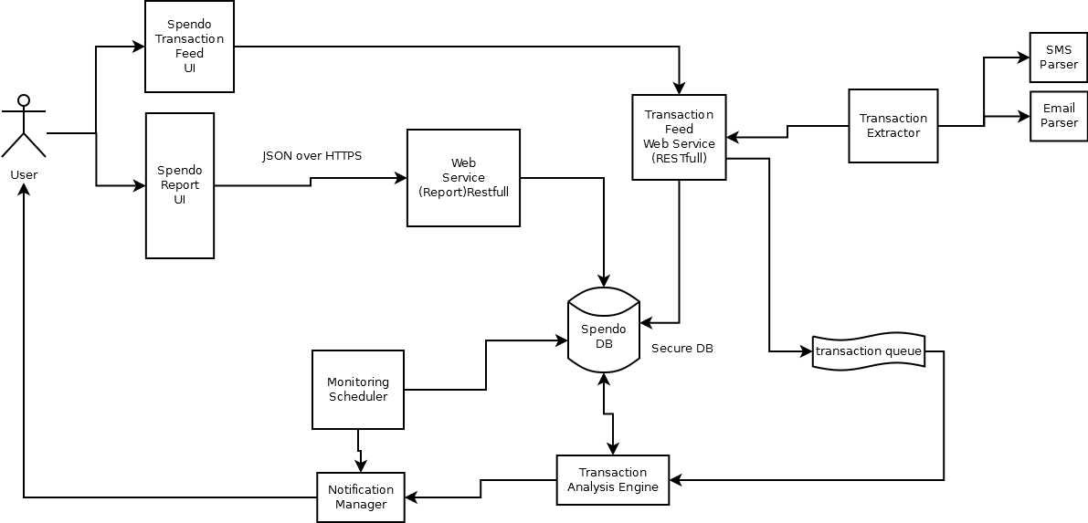
Technology Stack:
Entity | Technology
App Server | Jboss7/Wildfly9
Web Service Framework | Apache CXF with Spring4
Request/Response | JSON over HTTP
Database | mysql5.5
ORM | hibernate4
Caching Framework | ehcache3

DB Schema Design
